**BADI Implementation for XK02**

1. Go to tcode XK02. System-Status

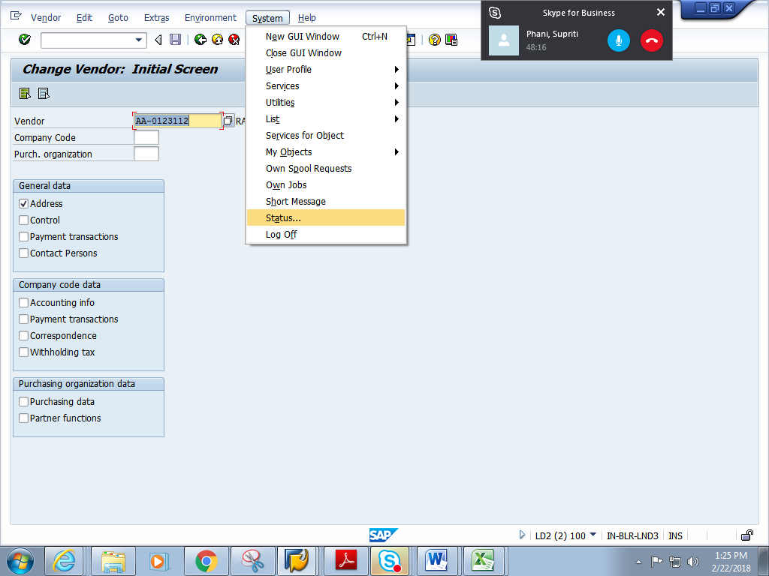

1. Copy the program name SAPMF02K

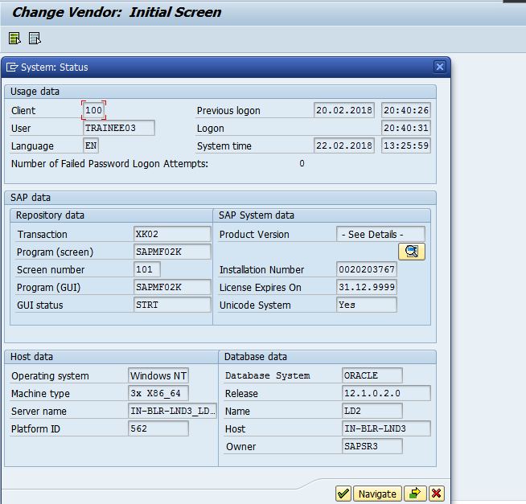

1. In se38 , go to attributes, get the package name of the Program SAPMF02K

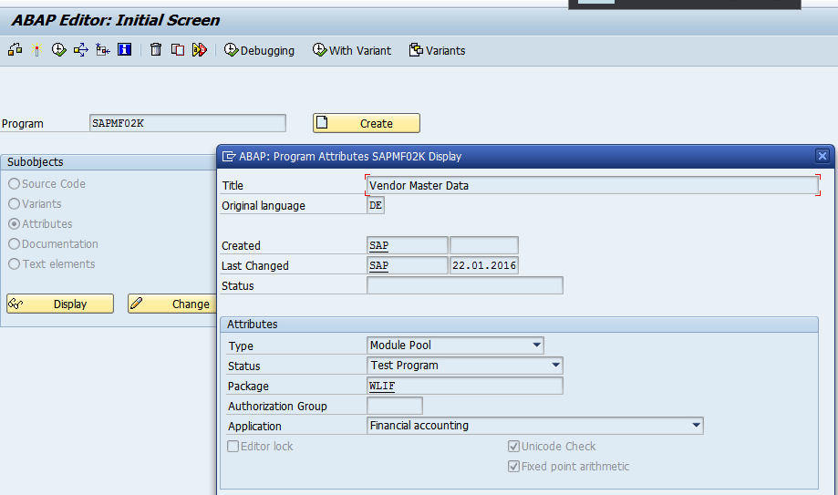

1. Go to Se18-> Click on F4 on BADI name

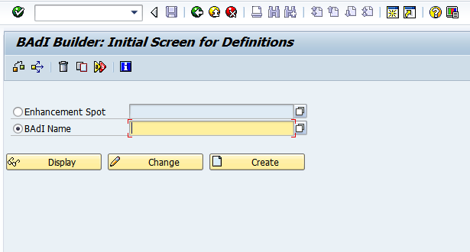

1. Click on information system

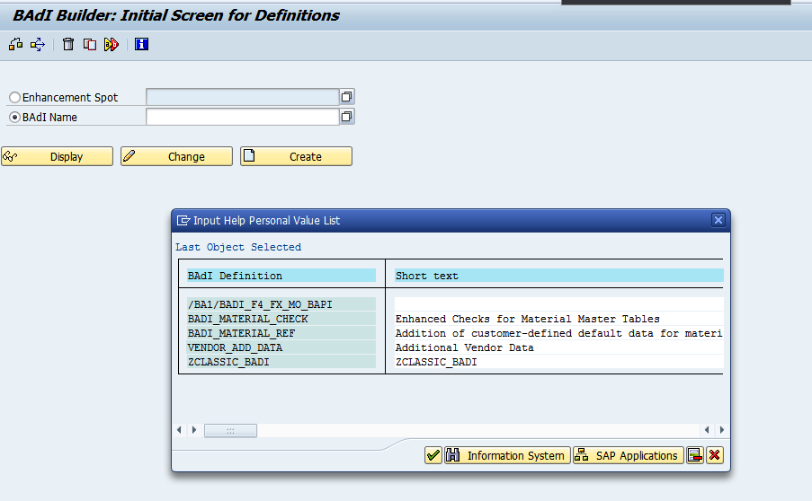

1. Give the Package name. Click continue

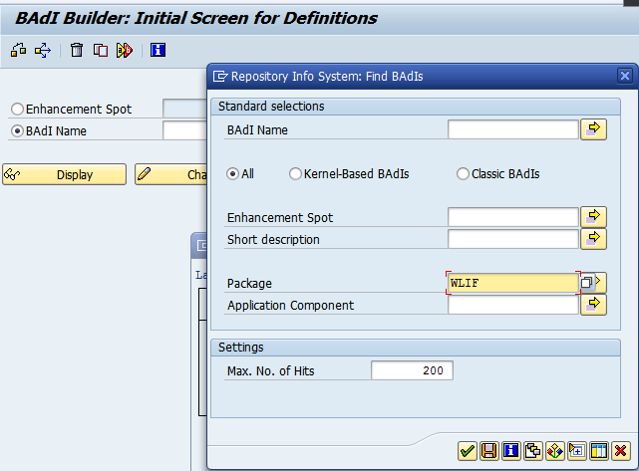

1. Choose the most relevant BADI definition. We choose VENDOR_ADD_DATA.

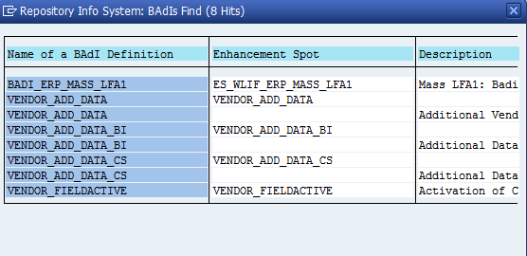

1. Go to SE19.In the create implementation section, choose Classic BADI and provide the BADI name VENDOR_ADD_DATA. Click on create

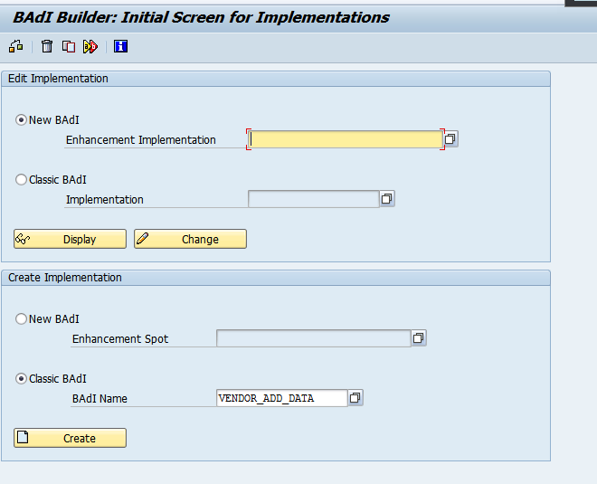

1. Give an implementation name starting Z/Y

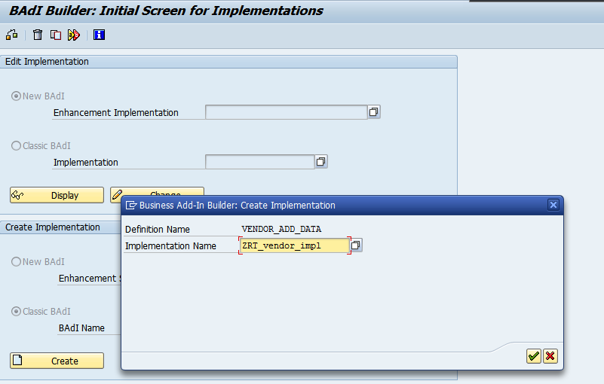

1. Provide short description, click on interface tab

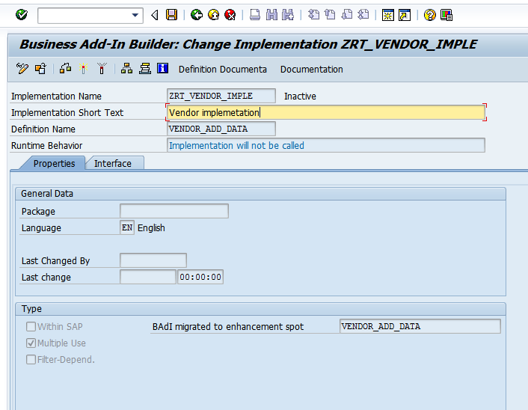

1. Double click on CHECK_ALL_DATA

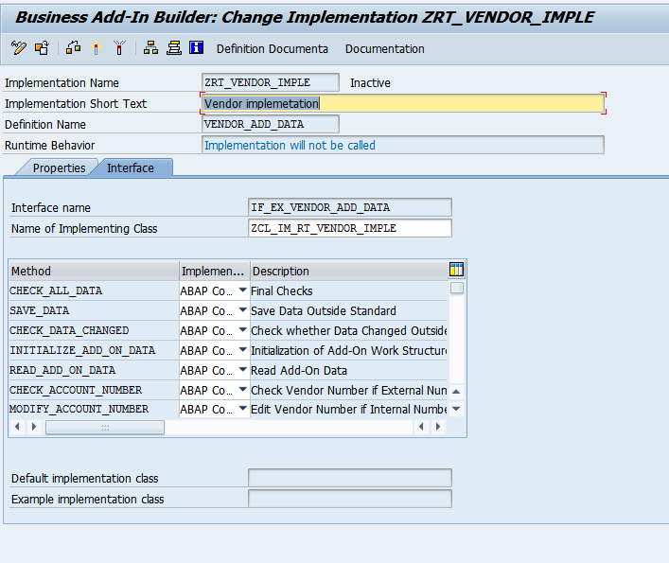

1. Click on yes

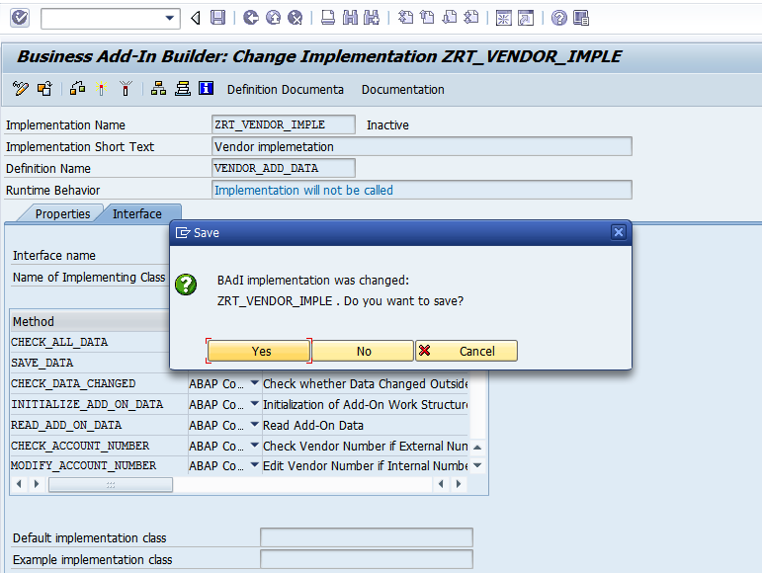

1. click on create

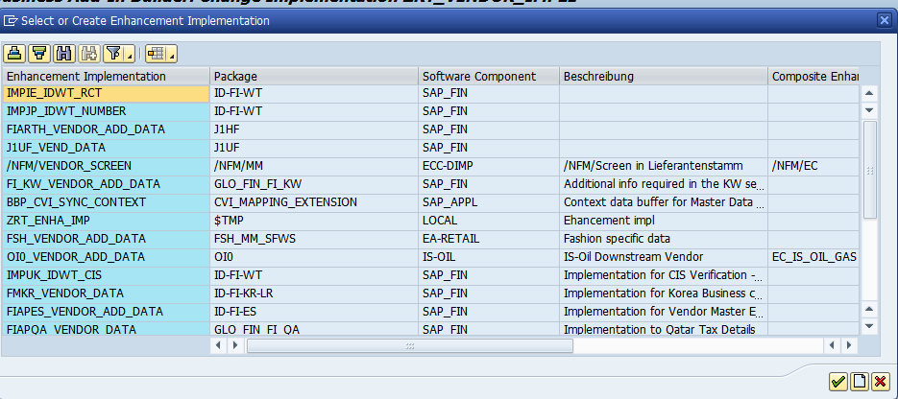

1. Give the following details. Click on continue

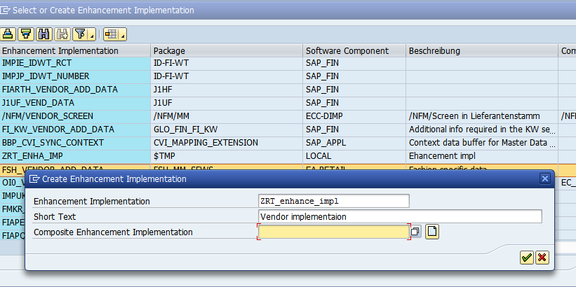

1. Choose the create enhancement implementation

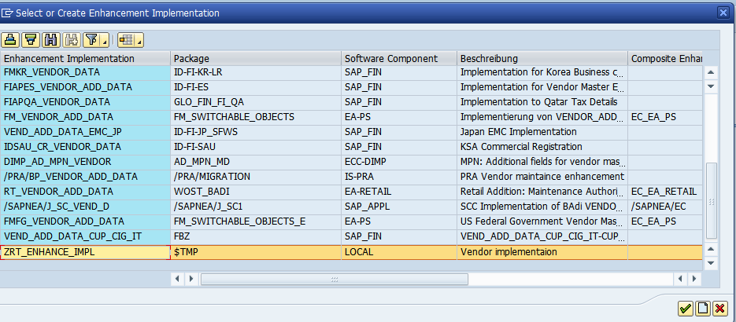

1. In the method, add the below code

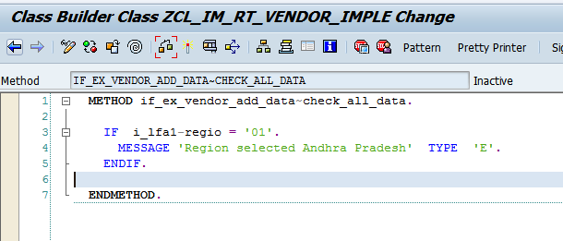

1. IF i_lfa1-regio = '01'.  
       MESSAGE 'Region  must not be 01 ( Andhra Pradesh)' TYPE 'E'.  
     ENDIF. Save and activate the method.
2. Save and activate the Implementation

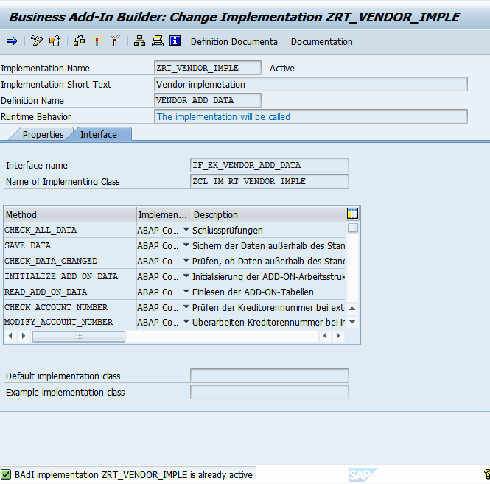

1. Go to table LFA1 and pick any vendor no. E.g. AA-0124
2. Go to XK02, Give the vendor. Check on Address

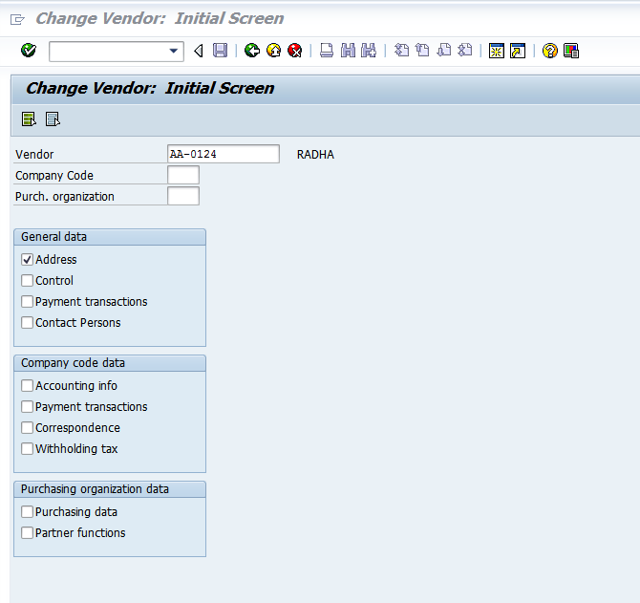

1. Give Region as 01

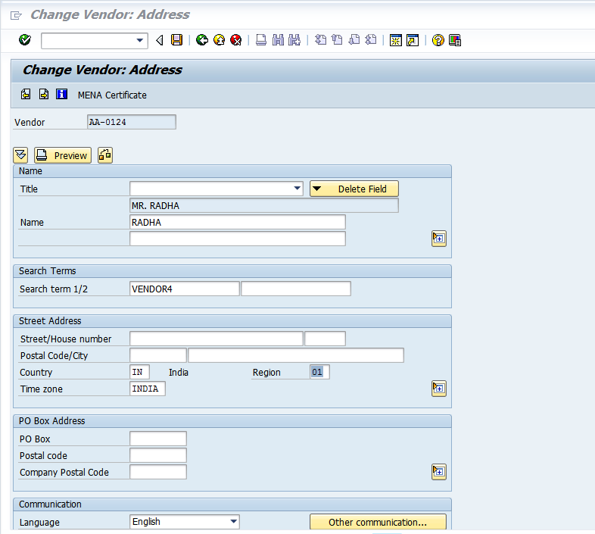

1. click on Save. You get the below error message

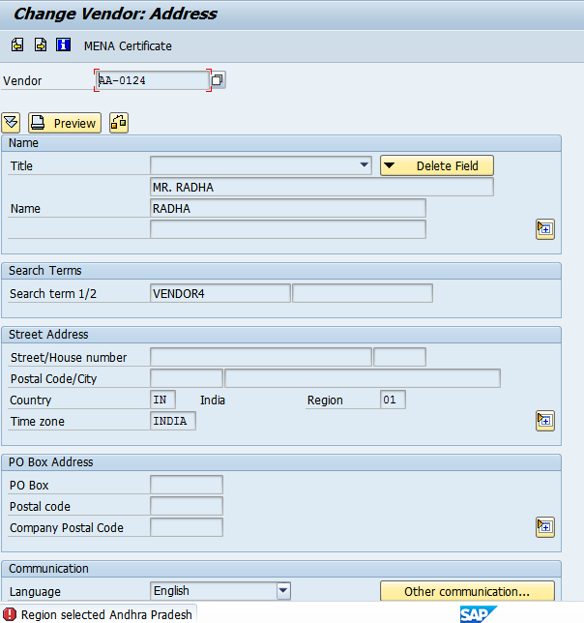

1. Deactivate the implementation by going to se19.Give the implementation. Click on change

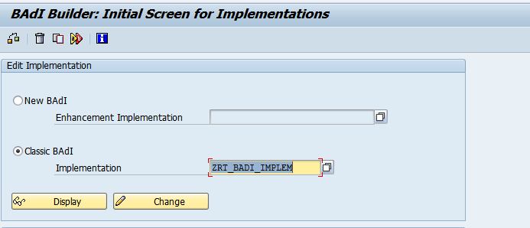

1. click on deactivate button

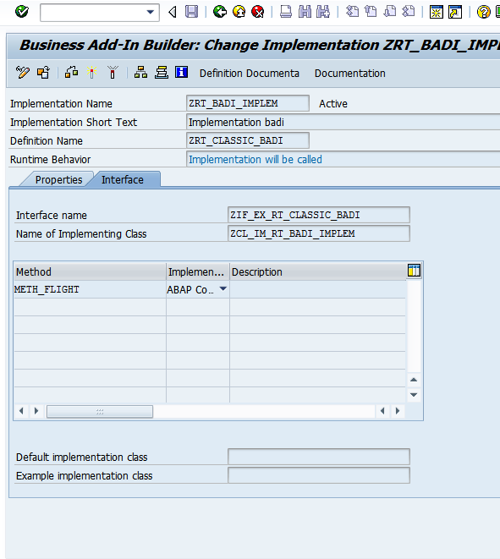

1. On deactivation, others will not get the error message if they choose region as 01.

